**E-Learning System**

**[Design Documentation]**

**Contents**

**1.** **Introduction** 2

**1.1 Purpose** 2

**1.2 Scope** 3

**1.1** **References** 3

**1.1** **Overview** 3

**2.** **Methodology** 3

**2.1** **Implementation of Design Model** 4

**3.** **Classes and Methods Design** 4

**4.** **Data Management Layer** 11

**5.** **User Interface Layer** 12

**6.** **Physical Architecture Layer** 16

**1.1.** **The Deployment Diagram** 16

1. **Introduction**

The basic purpose of this document is to present the detailed Design of the E learning system. Student and Teacher are the main parts of this system. By building this system, we will facilitate the student and the Tutors. Through this system, the Student can learn academic courses. Teachers can easily upload the video lectures and can put the price of whole course. Student can also enroll by paying the amount of course and at the end of the Course they will be certified by the system and Approved by the teacher.

**1.1 Purpose**

The purpose of this document is to present the detail design and provide some design and development strategies. This Document will show the Logical view and all the development phase. This Document is produced by team to provide the better design for the E-Learning system. This document can be used by the developer to bring more advance changes to this system.

## **1.2 Scope**

This document is intended for providing an abstract overview of Online Learning system and general overview of entire project. It will give the access to the student and the Teacher to share their important data and to do all activities between student and Teachers related to study safely. The scope of this document

* Implementation of Design Phase
* OOP design of the system
* Database Engineering
* UI design of the System
* Physical View of system

## **References**

The user of this SDD may need the following documents for reference

SYSTEMS ANALYSIS & DESIGN an Object-Oriented Approach with UML 5th Edition

## **Overview**

This document is written according to the standards for Software Design Documentation explained in “IEEE Recommended Practice for Software Design Documentation”. Sections 2 contains the Methodology we used to design the system. Section 3 contains the object-oriented code of the class Diagrams section 4 contains the UI prototype of the system section 5 have the ERD that elaborated the Database Engineering for the system and last phase describes the physical architecture of the document that how system will work in the real environment

# **Methodology**

To build this system Design we have used the V & V Model. Where WE gathered requirements are performed testing in Every Phase.

**Verification and Validation for class Design:**

For every class we have created a java code. All the java classes are according to the class Diagram. All the functions and methods are implemented.

**Verification and Validation for Use case:**

The Sequence Diagrams are created for every use case. To achieve the consistency in the design phase we followed the sequence Diagram flow in out prototype flow.

## **Implementation of Design Model**

There were three model in the choices to use to design this system**.**

* **Factoring**
* **Partition**
* **Layers**

The model we have used to design this system is defined below.

**Implementation of Layer Model**

While moving to the Design phase from the Analysis phase the layer model is used. The Implementation can clearly see in the Data Management Layer, UI layer and Physical Architecture Layer. By understanding the Layer model, we can understand the process better. Bu understanding the architecture model the deployment, UI and Data Management layer is designed. That helped us to understand the real environment of the system that where it will be use and how it will be structured to be used by the user. To successfully evolve the analyses phase into the Design phase we understood the real environment of the system. That actually represents the MVC Architecture of system. The views will handle the output and the controllers like java code will handle the input of the system and will perform other activities like authenticating the user and perform his wanted tasks in the system. The architecture layer is clearly defined in the Deployment Diagram that how system will be configured in the working environment and how components and Devices will communicate to each other to function properly

# **Classes and Methods Design**

All the classes and Methods Designed using the class Diagram. For every class there is a java file that is used to declare the classes and implement the functions in it. In the Diagram we have following classes:

* Lecturer
* Student
* Admin
* Course
* Video
* Payment
* Ratings
* Log in

Lecturer.Java

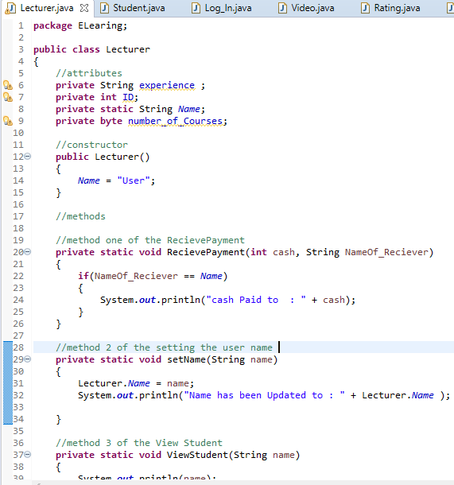

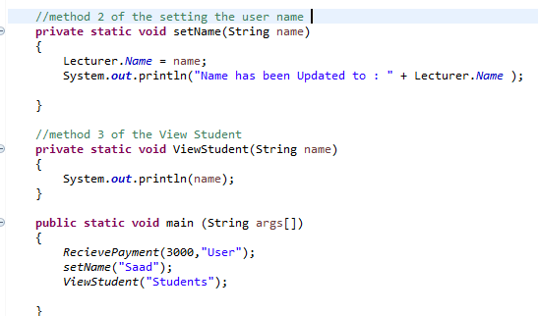

**Student.Java**

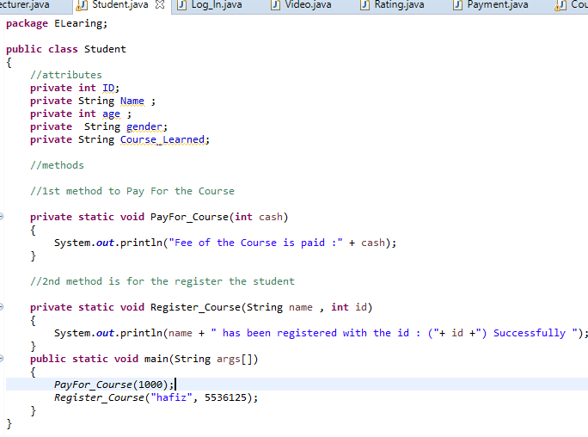

**Log in.Java**

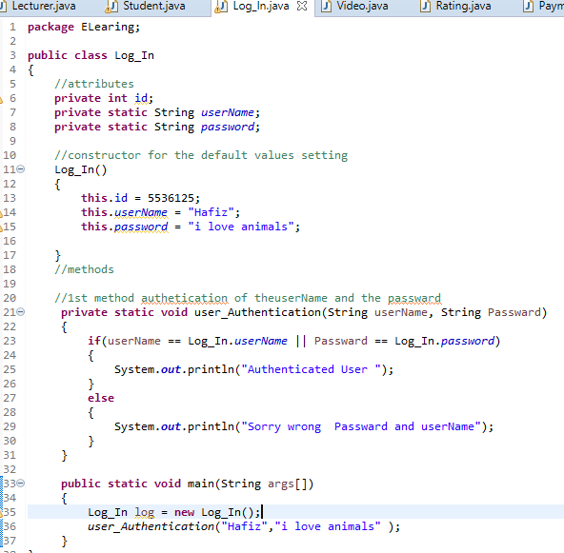

**Video.Java**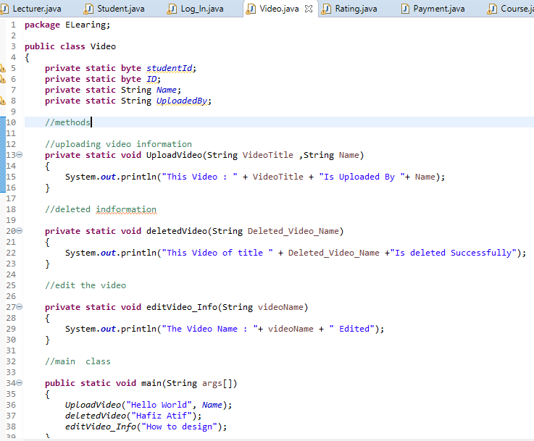

**Ratings.Java**

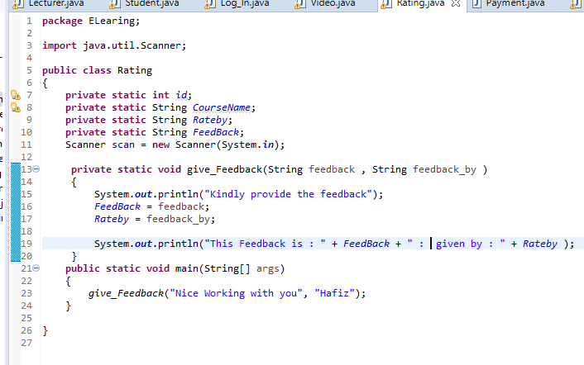

**Payment.Java**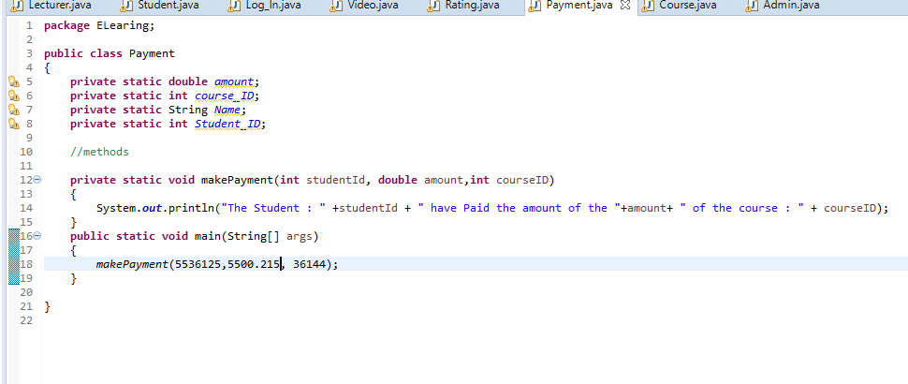

**Course.java**

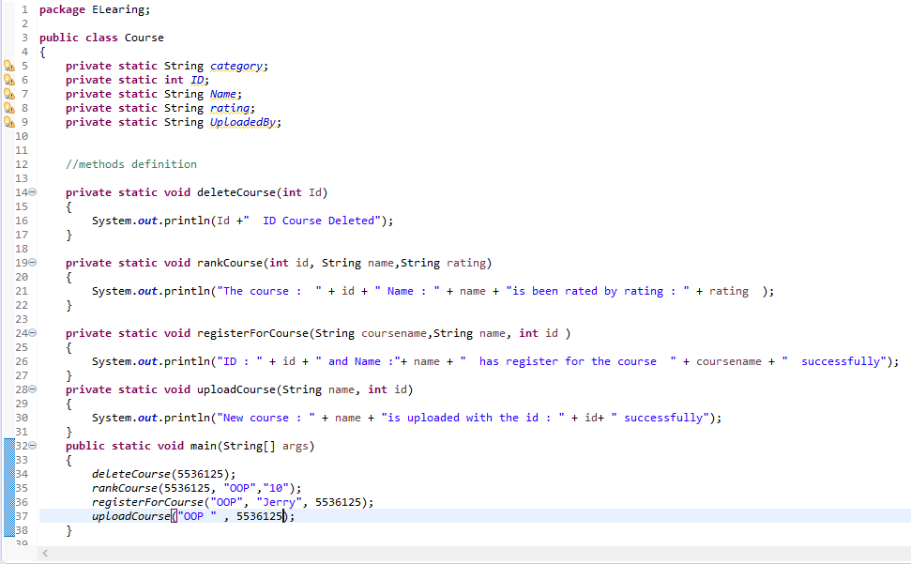

**Admin.java**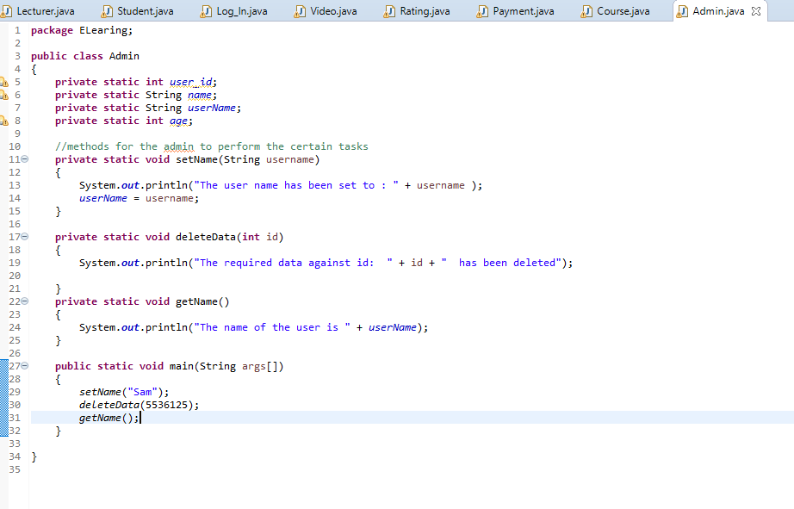

These are the classes Implemented Using Java Programming Language. We preferred Java because it is especially Object-oriented programming Language where classes are easy to build and we can easily define the relations among them. Class Diagram define the possible attributes and methods for different classes. Class Diagram is defined in the Part 1 document. The possible functions and attributes are implemented using java.

# **Data Management Layer**

The Data management Layer is all about managing the data in the Database where your system has data and you are going to save it in the Database. To do this activity Database Engineering is an Important activity we have done the Database Engineering and defined all the possible table with the primary key and Foreign keys. There also exists all the possible relations among each table.

**ERD for E learning System**

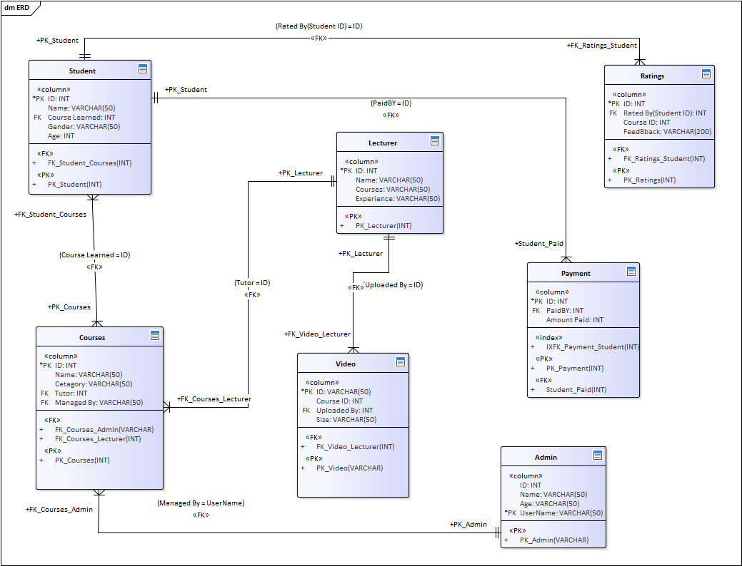

# **User Interface Layer**

The user interface layer is created using the Axure Prototyping software.

Axure is great prototyping software to design the high-fidelity prototypes easily.

**We tried following concepts to create a great design for this system.**

* **Layout:** We created a great Layout for the User.
* **Content Awareness**: Content Awareness is great where user can clearly define the
* **Aesthetics:** The design is great created using the great color combination
* **User Experience:** We hope the user experience will be great.
* **Consistency:** there exists the consistency in the design.
* **Minimal User Effort:** We tried to minimize the user effort to possible point.

**Usability:**

System will do the tasks which are intended to do the user’s tasks. Learning courses and navigating to the website. User can perform all the activities to learn from this system**.**

**Reliability:**

The system is reliable it will secure user’s data and will provide any type of security which needed to perform all the tasks.

**Memorability:**

The newly build system is memorable user can easily navigate to the website once he learned to do. He will not have to learn again and again to do the activities related to this system.

**Learnability:**

The system is easy to learn user will not find any difficulty learning this system. By reading and understanding user can learn himself how to use this system.

**Security:**

The system needs to log client’s information of registration such as IP address and time for security purpose. Password should encrypt and store in the database. The System is fully secure and provides full comfort zone to user to use this system. All the Information is secure to store in the Database and it will be a agreement for user that his/her information will not be shared.

**Maintainability:**

The System is build using Easy techniques of coding the maintainability can be achieved because it is not difficult to read the code any require changes after the Deployment will be made easily.

**Home Page:** 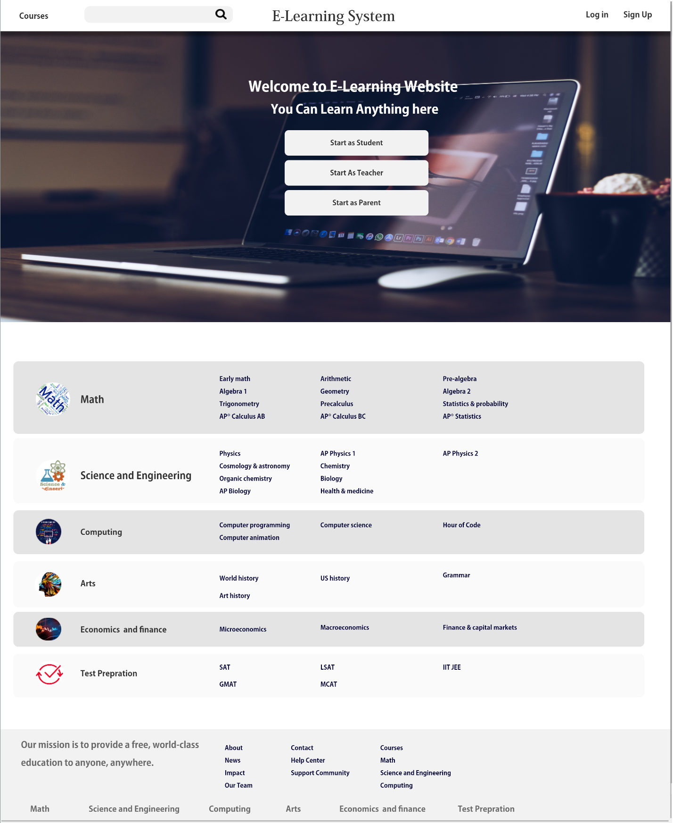

**Courses page:**

**by clicking on**

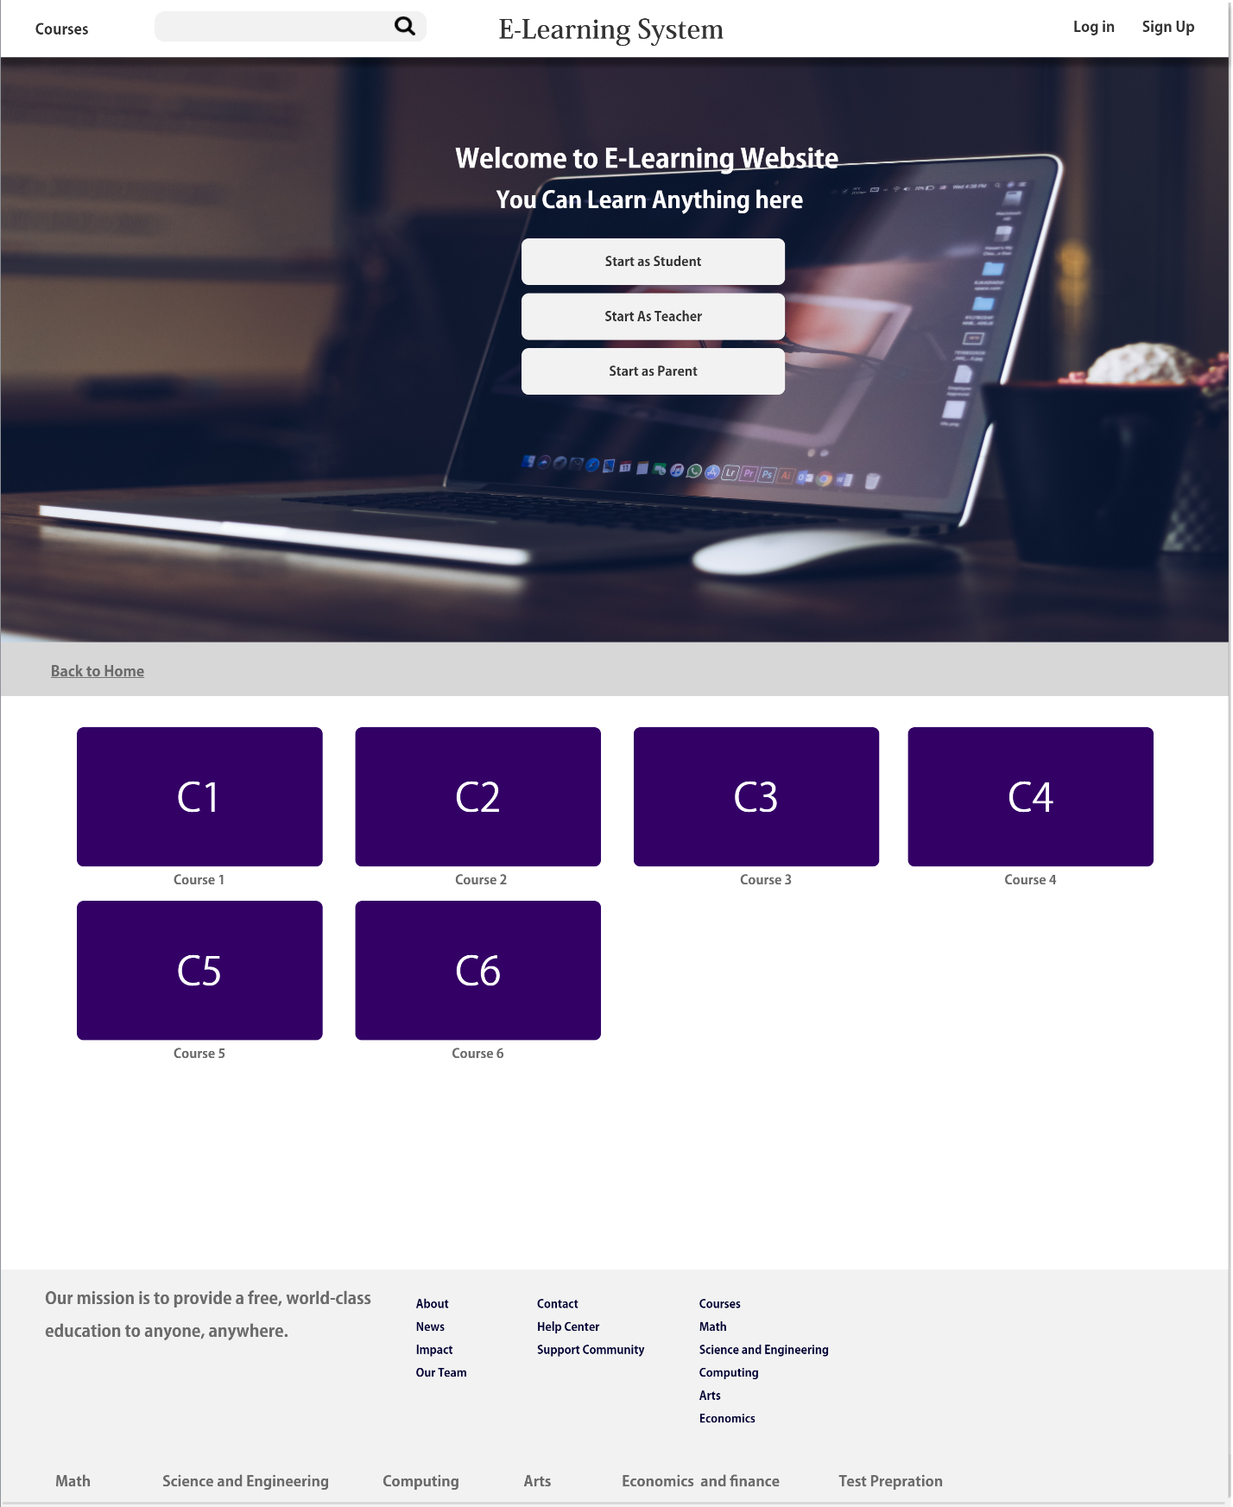

**By clicking on the any course, it will take the user to the Lectures page**

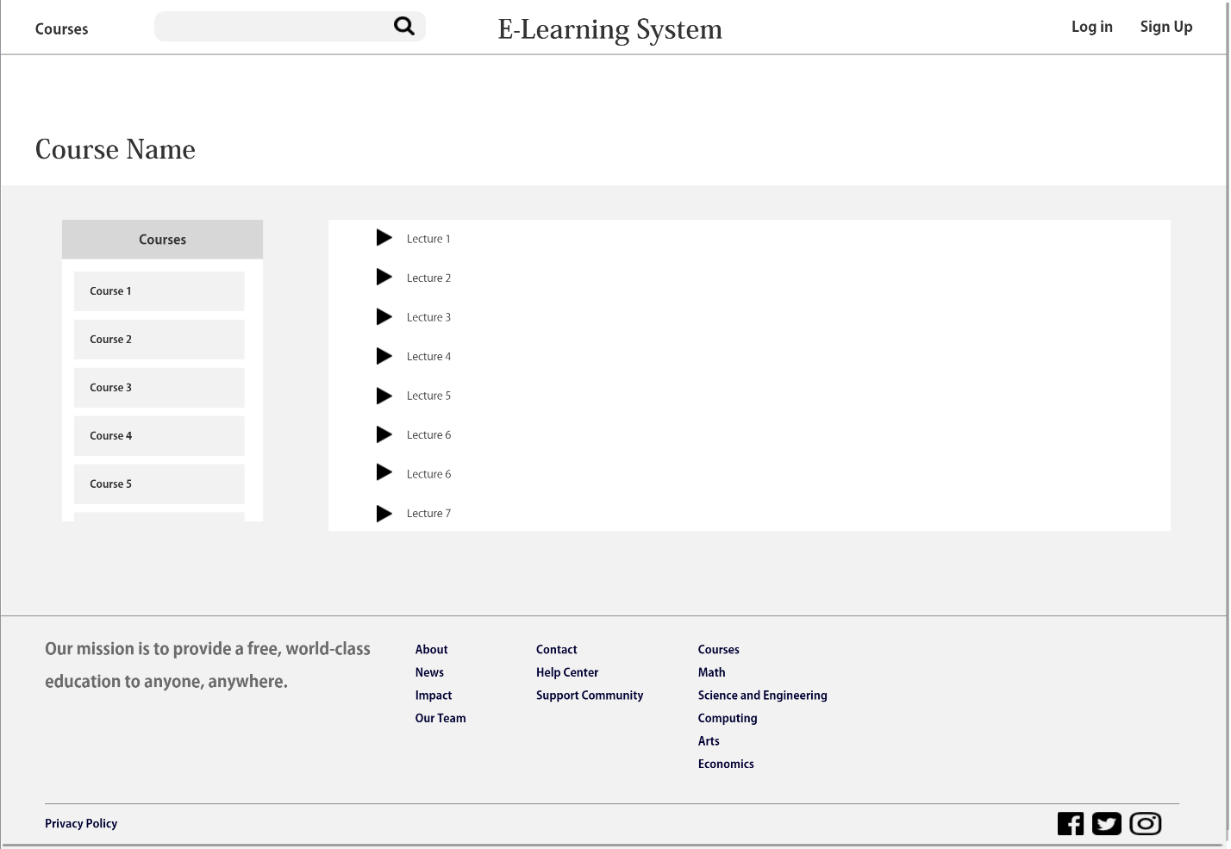

**By clicking on the lecture, it will play the video of lecture**

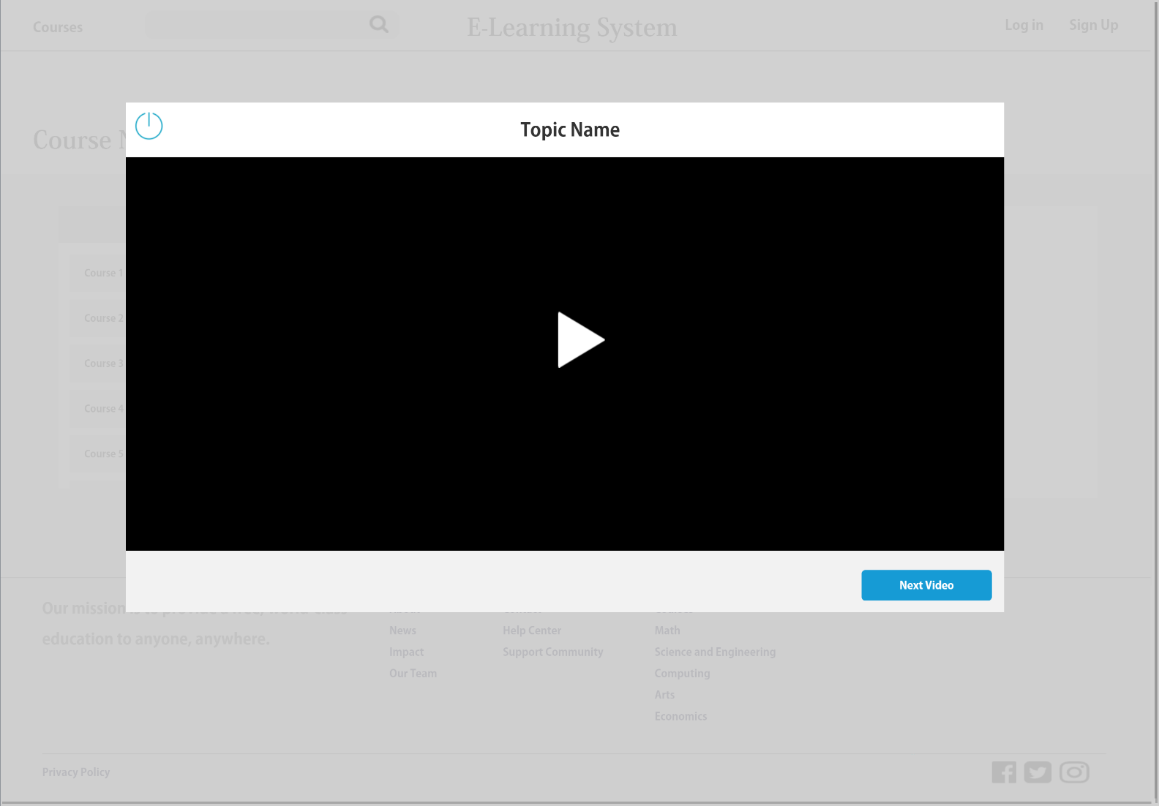

# **Physical Architecture Layer**

This phase will show that how this system will work in an environment where user can use it.

**Architecture:**

There is three tier architecture for this web application. Where user will user the system and system will have web browser and browser will contact to server for website and that website will use the database server which contains our database.

**Environment:**

The Desktop should have browser and the operating system does not matters. By using the Browser of Mobile, iPad, and Desktop the user can access this system using a stable internet Connection.

**Application Type:**

The Application is a web Application and can be accessed using the Internet Connection. User Can access it from any device.

**The Deployment Diagram will clear Everything About system Environment.**

## **The Deployment Diagram**

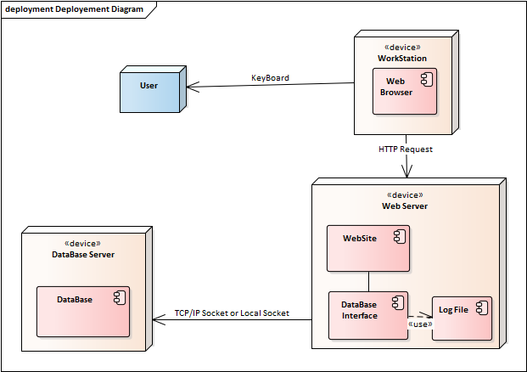

**(Using Chapter 11)**